Year 11

Human Biology Excretion/Digestion Test Revision

Which organ in the digestive system creates the following enzymes, and what reactions do they facilitate?

Amylase ____________________________________________________________________________________

Protease ____________________________________________________________________________________

Lipase _____________________________________________________________________________________

Lactase _____________________________________________________________________________________

What is Cellulose useful for in digestion

_____________________________________________________________________________________________

What is the function of bile, and describe its pathway in the digestive process

_____________________________________________________________________________________________

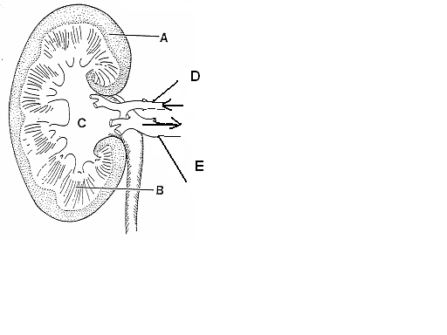

Label parts of the kidney

Name and specify parts of the alimentary canal that: -

absorb nutrients ____________________________________________________________________________

that perform peristalsis _______________________________________________________________________

that perform defecation ______________________________________________________________________

Draw and label parts of a villus and describe where they are found in the digestive system

Describe villus’ function and what makes its physical attributes suitable for its function

___________________________________________________________________________________________

___________________________________________________________________________________________

Describe the role played by each structure in excretion

Lungs _____________________________________________________________________________________

Sweat glands _______________________________________________________________________________

Alimentary canal ____________________________________________________________________________

Kidneys ____________________________________________________________________________________

Liver ______________________________________________________________________________________

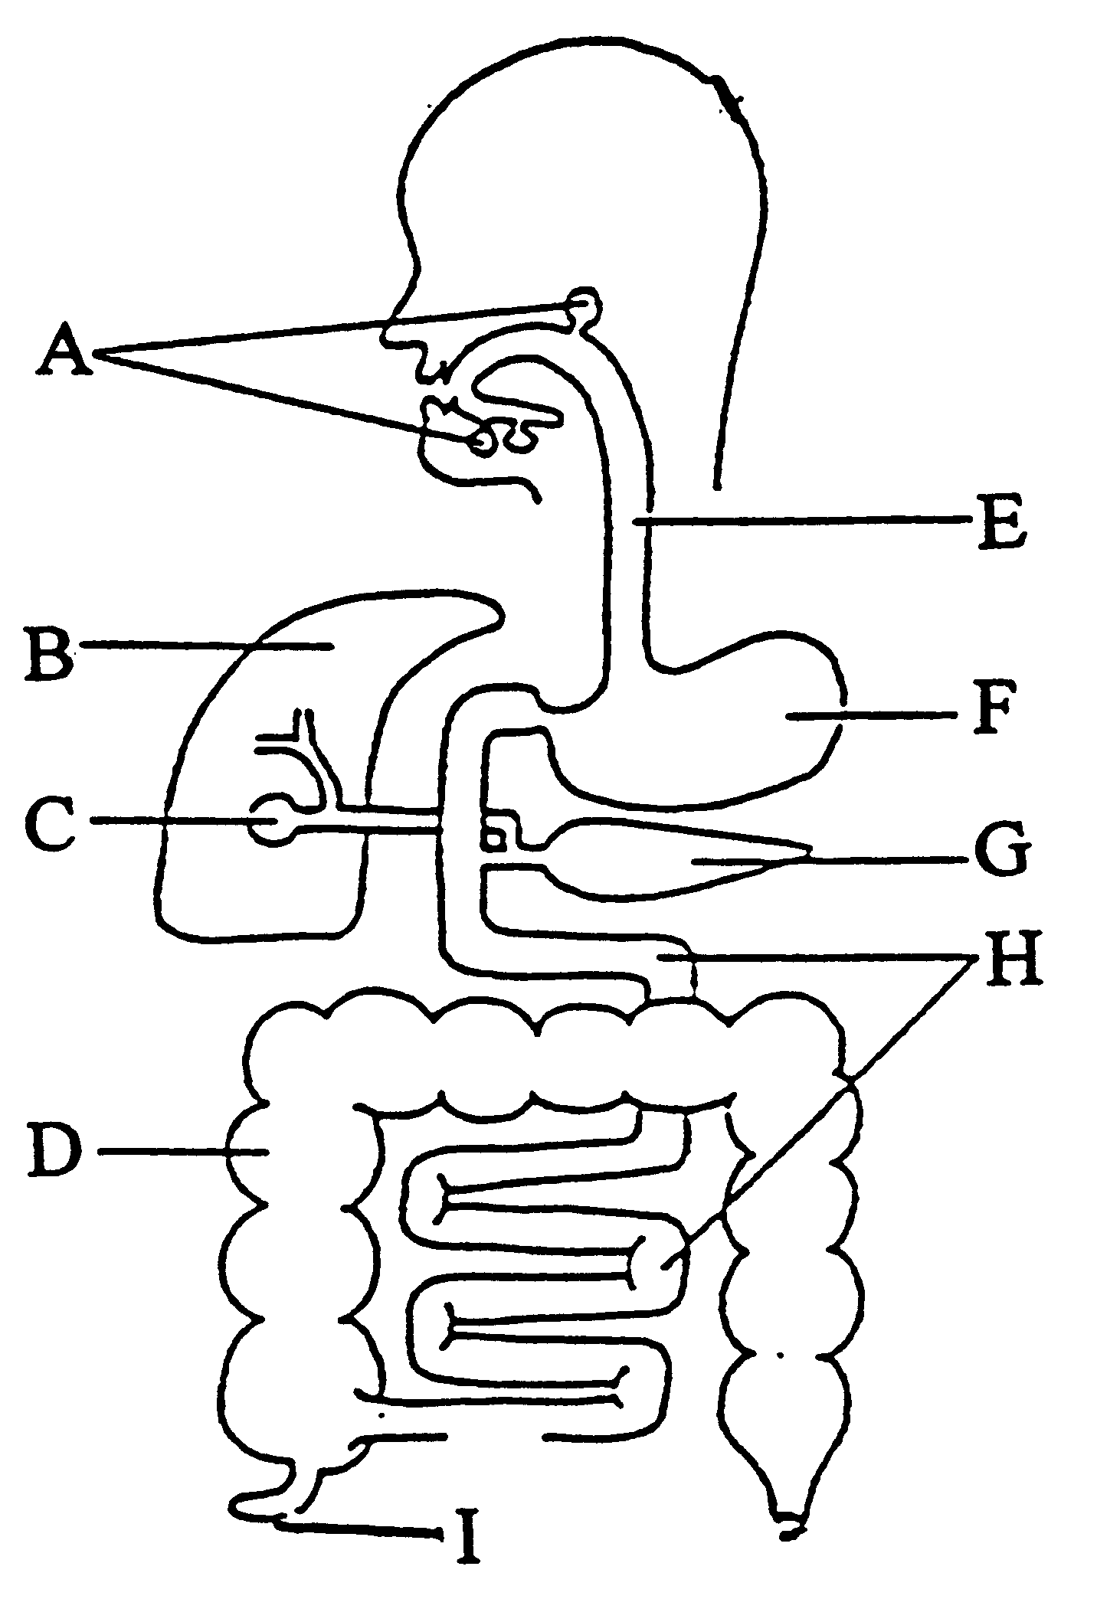Label the organs of the digestive system

Describe where protein is mostly digested and by what enzyme

_______________________________________________________________________________________________

Define the following terms

Defaecation _____________________________________________________________________________________

Excretion _______________________________________________________________________________________

Elimination _____________________________________________________________________________________

Filtration _______________________________________________________________________________________

Abdominal cavity ________________________________________________________________________________

Cortex _________________________________________________________________________________________

Micturation _____________________________________________________________________________________

Urethra ________________________________________________________________________________________

Ureter _________________________________________________________________________________________

Renal __________________________________________________________________________________________

Urine __________________________________________________________________________________________

Deamination ____________________________________________________________________________________

Compare the contents of the fluids in the renal arteries to the renal veins

_______________________________________________________________________________________________

_______________________________________________________________________________________________

_______________________________________________________________________________________________

Why is ammonia converted to urea? _________________________________________________________________

_______________________________________________________________________________________________

Why is urea excreted? ____________________________________________________________________________

_______________________________________________________________________________________________

What is urine and what substances does it normally contain? _____________________________________________

_______________________________________________________________________________________________

Why are excess proteins deaminated? _______________________________________________________________

_______________________________________________________________________________________________

What is the name of the structure that INITIALLY filters the blood in the kidney? ____________________________

What happens to the urine output if the body fluids contain less water? ___________________________________

Describe why “detox” and “cleanse” fads are a scam ___________________________________________________

______________________________________________________________________________________________

______________________________________________________________________________________________

______________________________________________________________________________________________

______________________________________________________________________________________________